## Skill-React

# React Hands-on Lab: Officespacerentalapp

# Code:

## Terminal Instructions:

**# 1. Create the React App**

**npx create-react-app officespacerentalapp**

**# 2. Navigate into the project folder**

**cd officespacerentalapp**

**# 3. Start the development server**

**npm start**

# Code(App.js):

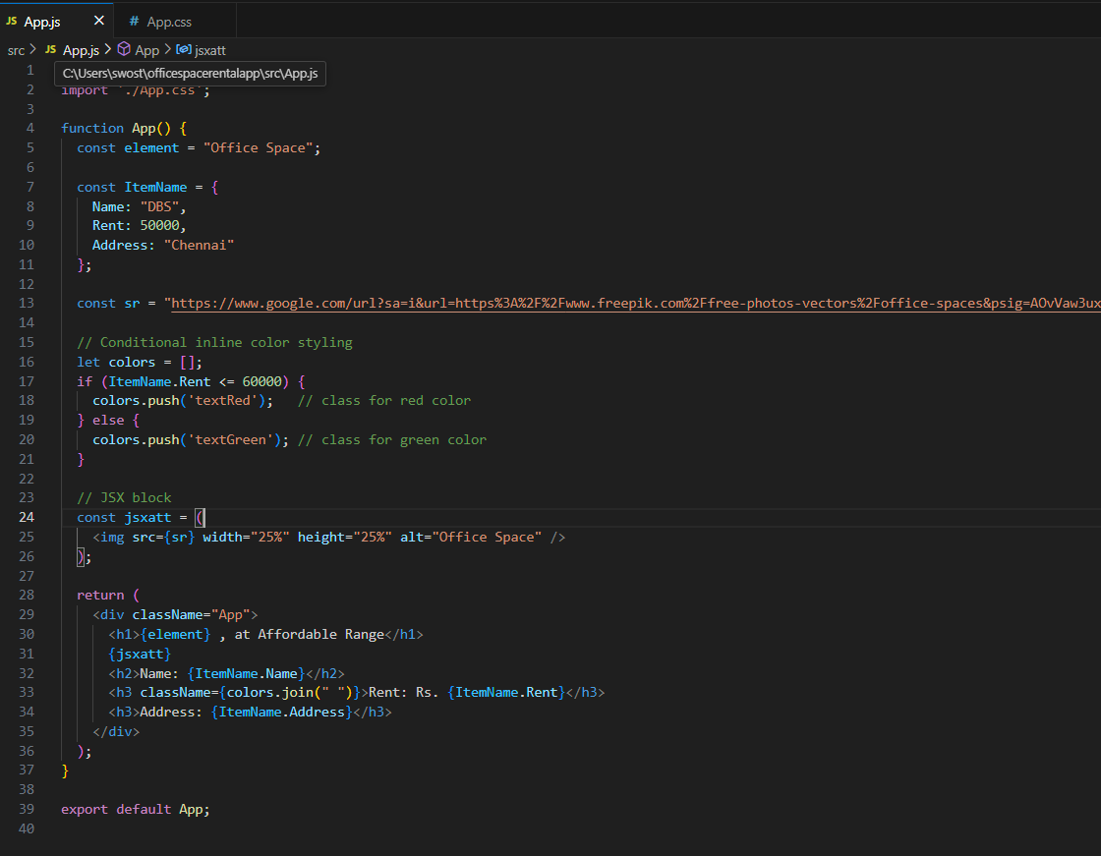

## App.css:

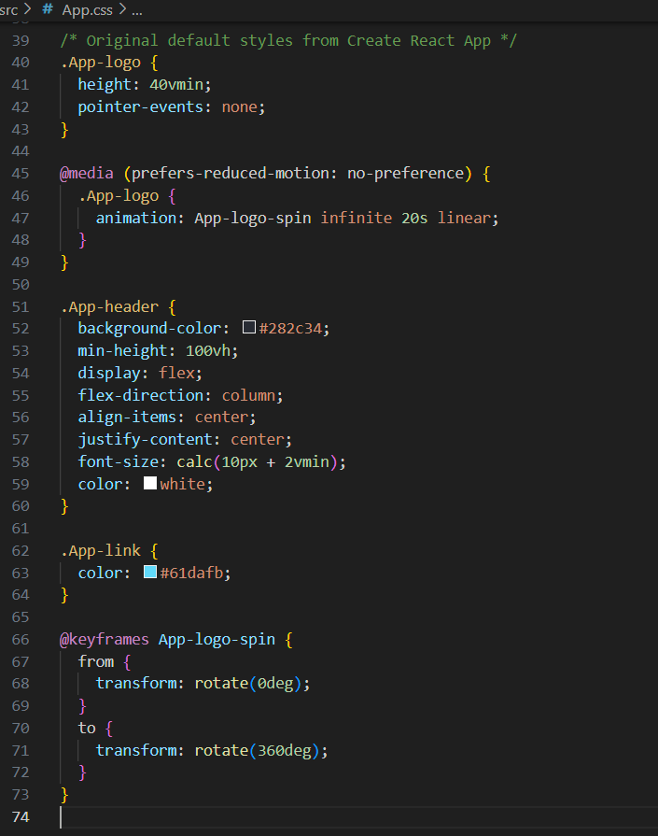

# Output:

